Determining Breed Times and Whelping Dates
Veterinary & Aquatic Services Department, Drs. Foster & Smith

There are multiple hormones that help to regulate the estrus (heat) cycle and pregnancy in dogs. These include:
- Estrogen: Stimulates the ovaries to produce eggs.
- Luteinizing Hormone (LH): Stimulates the ovaries to release the eggs.
- Progesterone: Maintains a pregnancy.
Understanding how the hormone levels change can help in determining the best time to breed and when to anticipate whelping.
Most mammals ovulate when the estrogen level in the blood is increasing. Dogs, however, ovulate when the estrogen level is declining and the progesterone level is increasing. Estrogen levels can give us a general idea of when a dog will come into heat, but are not sufficient to determine when breeding should actually take place. Vaginal cytology can also provide some general information. Progesterone levels and luteinizing hormone (LH) levels are the best indicators of when ovulation will take place and when is the best time to breed. They are also useful in determining whelping dates, allowing an owner to reserve the appropriate days on the calendar and even to schedule a c-section (caesarean) weeks in advance.

Luteinizing hormone levels
LH is species-specific, meaning it is chemically different in different species. Blood testing for LH, therefore, needs to be done at a veterinary lab or at a veterinary clinic where access to the specific test for that species is available. Test results are generally available within less than 24 hours of submitting the sample.
The LH test needs to be done daily starting toward the end of proestrus. The LH spike typically lasts only 24 hours or less, so the test needs to be done every 24 hours in order to catch it. If the testing starts too late, the spike will be missed. The spike generally occurs 48 hours prior to ovulation.

Figure 1. Hormone Levels During Estrus and Pregnancy
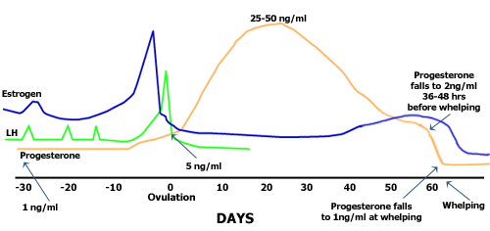

progesterone levels and breeding
The progesterone test is not species specific so the test can be run in human labs or veterinary labs. Results should be available in less than 24 hours.
The progesterone test can be done every 2-3 days starting about 3-5 days into the heat. Timing of the test can be more certain if the lengths of the dog's previous heat cycles are known. The beginning progesterone levels are typically less than 1.0 ng/ml until the day before the LH surge. The day of the LH spike, serum progesterone concentrations are 2-3 ng/ml; the day following the LH surge, the serum progesterone concentration is 3-4 ng/ml. Ovulation occurs at a progesterone level of 5 ng/ml.

Figure 2. Predicting Breeding Time And Whelping
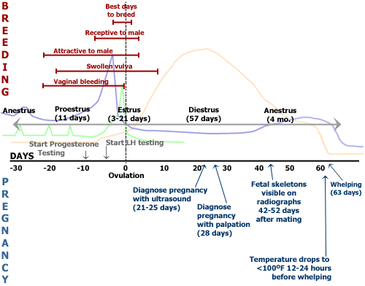

Timing of breeding
The aim is to identify when the progesterone level reaches 2.5 ng/ml so the mating schedule can be set up, or the veterinarian and owner of the male dog can be notified that they should be prepared to collect and ship a semen sample. Depending upon the type of semen used, optimal times for natural or artificial insemination are:
- Natural breeding should occur 3 days after the 2.5 ng/ml mark. Sperm in fresh semen survive 5-7 days after insemination.
- Artificial insemination using fresh chilled semen should be used for a 1-time breeding. Insemination should take place 4 days after the progesterone reaches the 2.5 ng/ml mark or 48 hours after the 5 ng/ml mark. Sperm in chilled semen survive 48-72 hours after insemination. With artificial insemination, the semen should be deposited into the cervix to increase the chance of it being drawn into the uterus.
- Artificial insemination using frozen semen should be performed 5 days following the 2.5 ng/ml mark or 72 hours after the 5 ng/ml mark. Sperm in frozen semen survives less than 24 hours after insemination. Frozen semen is ideally deposited directly into the uterus through surgery to increase the chance of pregnancy.

Fertilization and implantation
The sperm require a period of approximately 7 hours after ejaculation before they are capable of fertilizing an egg. This period is referred to as the "capacitation time." The egg also needs time to mature after it is ovulated, generally 48 hours from ovulation until it can be fertilized. Fertilization occurs in the oviduct (Fallopian tubes) regardless of the method of insemination. The fertilized egg then travels into the uterus but does not implant until 17-18 days after ovulation. If there are problems with the lining of the uterus, the egg may not implant or the placenta may not grow or be maintained. A normal placenta grows into the lining of the uterus. If implantation does not occur or the placenta does not grow normally, the fetuses are resorbed.
Progesterone levels during pregnancy and whelping
After ovulation, progesterone concentrations continue to increase for 2-3 weeks, finally reaching 10-80 ng/ml. This level is necessary to maintain a pregnancy. In the dog, the progesterone level will remain at this level for about 60 days whether or not the dog is bred, and whether or not she is pregnant.
About 48 hours before whelping, the progesterone level drops to the 2 ng/ml range and within about 24 hours of whelping, the level drops to the 1 ng/ml range. This can help determine the proper timing of a c-section, especially if the progesterone level or LH level were not used to determine the ovulation date. By correctly determining the whelping time, it can prevent puppies from being taken by c-section too early and thereby decreasing their chance of survival.
The following chart indicates the estrus cycle (by days), the hormone levels, breeding times, and whelping dates.
Day | Estrogen Level | Progesterone Level | Luteinizing Hormone (LH) Level | When To Breed Based On Semen Type | Whelping Indicators
-3 day | High | < 1 ng/ml | Low | – | –
-2 day | Moderate | 2-3 ng/ml | Surge | – | –
-1 day | Low | 3-4 ng/ml | Low | – | –
0 (ovulation) | Low | 5 ng/ml | Low | – | –
+1 day | – | > 5 ng/ml | – | Natural semen | –
+2 day | – | > 5 ng/ml | – | Fresh chilled semen | –
+3 day | – | > 5 ng/ml | – | Frozen semen | –
+2-3 weeks | – | 10-80 ng/ml | – | – | –
+62 day +/- 1 | – | 2 ng/ml | – | – | Temperature drops
+63 +/- 1 | – | 1 ng/ml | – | – | Whelping
= Less than > = Greater than

