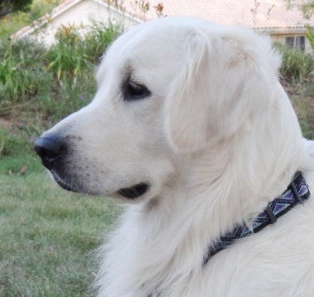
Puppy Adoption Questionnaire
Shilos Arctic Star
Shilos Arctic Star
Thank you for your interest in our English Cream Golden Retriever puppies. Our goal is to find loving, well-suited homes for each and every one of our Shilos Arctic Star-Sired “Golden Treasures”. Please complete the following questionnaire in order to help us make appropriate decisions for adoptions. If approved we will require a deposit of $500.
Your Name:
Phone(s) (include area code):
Best Day/Time to speak:
E-mail Address:
Home Address:
City/Town:
State: Postal/Zip Code:
How did you hear about us?
What Sex of puppy are you interested in? Male Female Either
When would you like to add a puppy to your family?
For what purpose(s) are you interested in a Golden Retriever?
Family Pet Obedience Agility Conformation
Field Events Hunting Breeding Service/Therapy
Our puppies are sold on a Limited - Non-Breeding Contract (special exceptions reviewed by both Dam and Sire owners). Will you honor this consideration? Yes No
Are you currently on a waiting list for any other litters? Yes No
Do you have children that live at home? Yes No If Yes, please answer the following:
List the ages of your resident children:
Are your children comfortable around dogs? Yes No
Type of residence? Detached House Condominium Apartment
What is your property arrangement? Own Lease/Rent
Do you have a large fenced yard? Yes No Approximate size? Sq. ft.
Is someone home during the day, or able to get home to "potty" puppy? Yes No
Will puppy have regular contact with its family during the day? Yes No
Will puppy have regular contact with its family during the evening? Yes No
Where will your puppy sleep?
Will you be interested in taking obedience/training classes? Yes No
Have you ever owned a Golden Retriever before? Yes No
If NO, why are you interested now?

If you haven't owned a Golden before, what other breed of dog(s) have you owned? (If you haven't owned a dog before, please state.)
Please list current dogs and/or cats, and their ages:
Do you already have a veterinarian capable of tending to your puppy? Yes No
Do ALL family members agree on the addition of a “Golden” to the family? Yes No
Who will have primary responsibility for care of your puppy?
Have you ever given up a dog to a shelter or pound? If so, why?

Please provide the following information:
Preferred Adult Dog Weight/Size:
Personality, e.g. laid-back, active, inquisitive, easy-going, dominant, submissive, etc.

Activities you like to participate in, e.g. kid’s play, hiking, jogging, hunting, travel:

Please share other information below, that may help us to appreciate your specific wants and needs related to that perfect family addition:

Thank You,
Shilos Arctic Star
Shilos Arctic Star-MarMic LLC - La Cresta, CA – www.shilosarcticstar.com – info@shilosarcticstar.com

